Week 8 zipn file (learning cuda)
1.
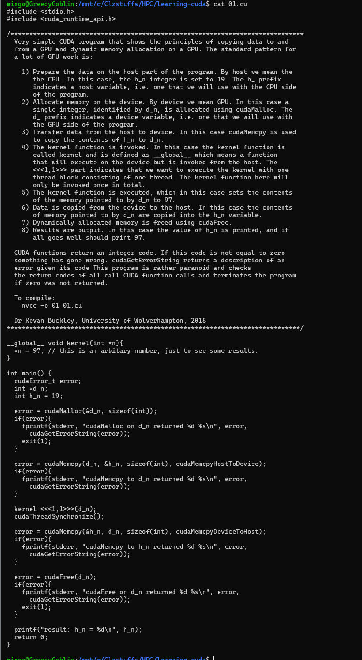
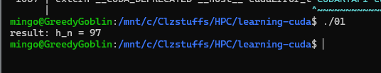
This CUDA program demonstrates a basic workflow for using a GPU. First, you prepare data on the CPU (host) and allocate matching space on the GPU (device). You then copy the data from the CPU to the GPU and run a special function called a "kernel" to process it. Once the GPU finishes its task, the results are copied back to the CPU, and the GPU memory is cleaned up. Throughout the process, the program checks for errors at every step to ensure the hardware is communicating correctly, ultimately displaying the final result.

2. 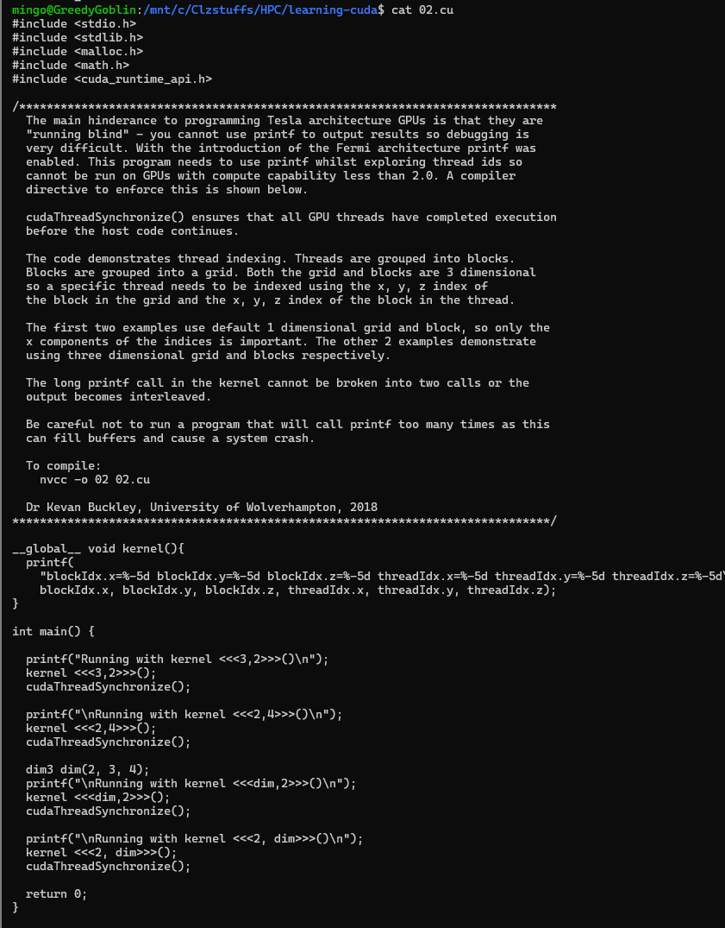
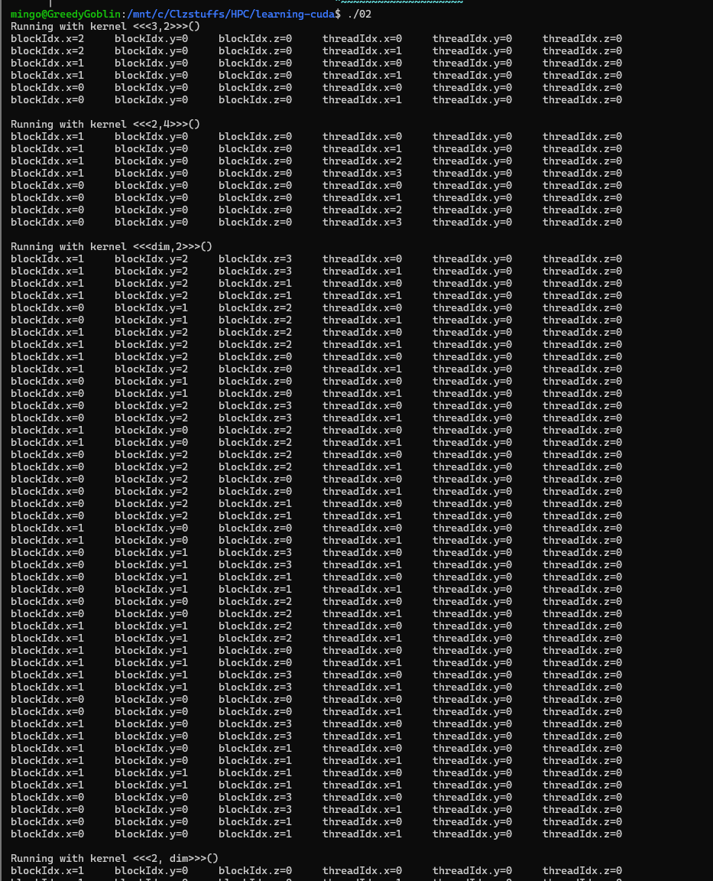
Newer GPUs allow programmers to use the "printf" command to see what is happening inside their code, which makes debugging much easier than on older models. This program uses that feature to show how GPU threads are organized into 3D groups called blocks and grids. By using specific coordinates, the program can identify every individual thread and track its work. It also uses a synchronization command to make sure the CPU waits for the GPU to finish everything before moving forward. While this is a great way to learn how threads work, it is important not to print too much information at once, as it can overload the system and cause a crash.
3.
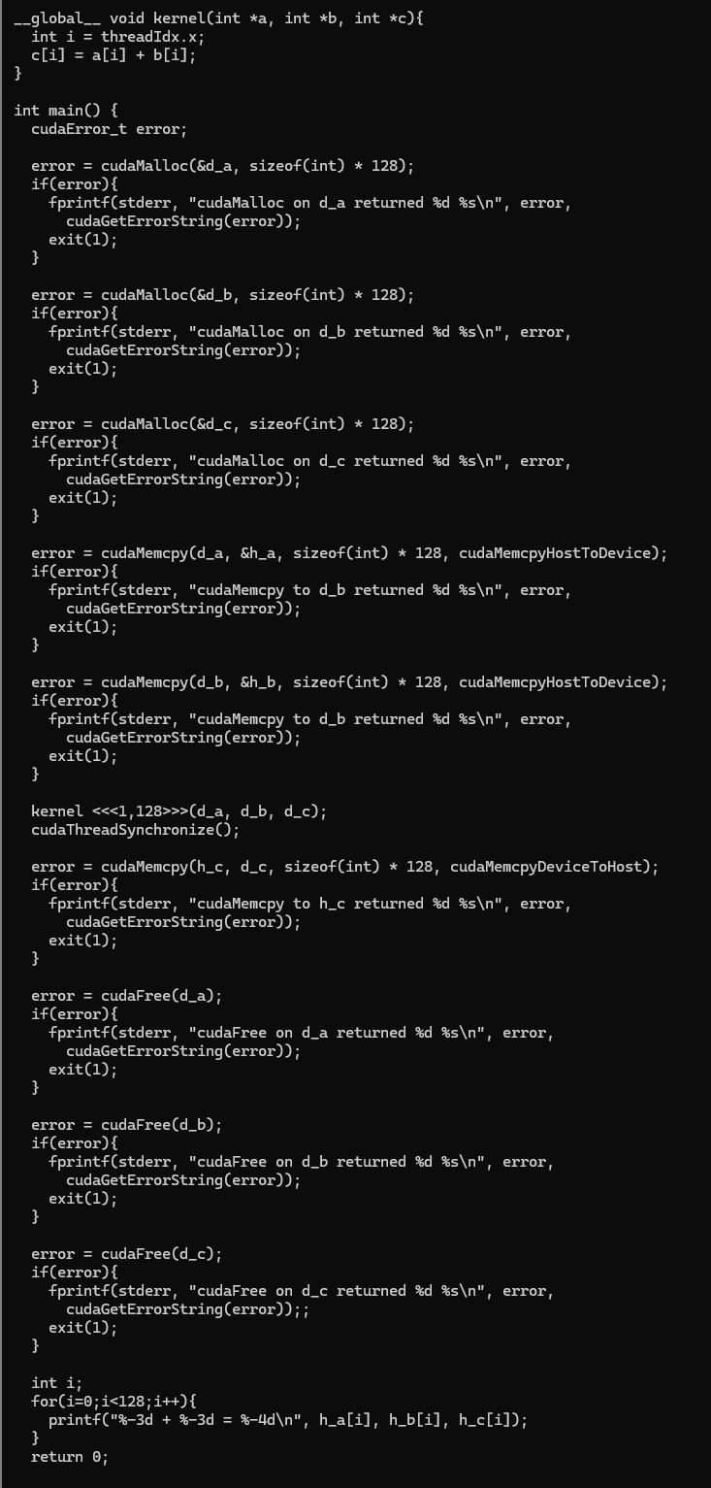
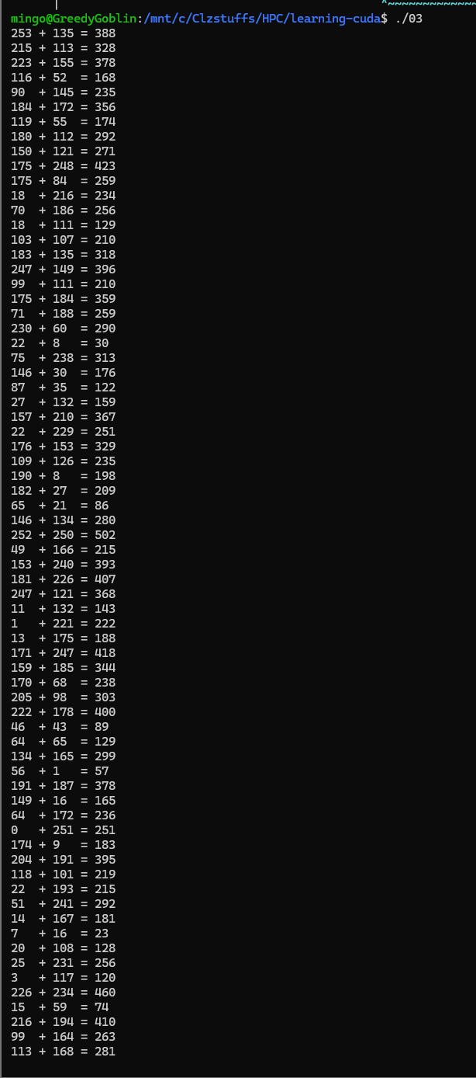
This program demonstrates how to add two lists of numbers together using the GPU. Because the lists are small, the work is handled by a single group of threads. The process involves setting up memory on the GPU, copying the input data over, and then copying only the final results back to the computer once the calculation is done. A simplified version of this code is also available without error-checking to make the core steps easier to see.

4.
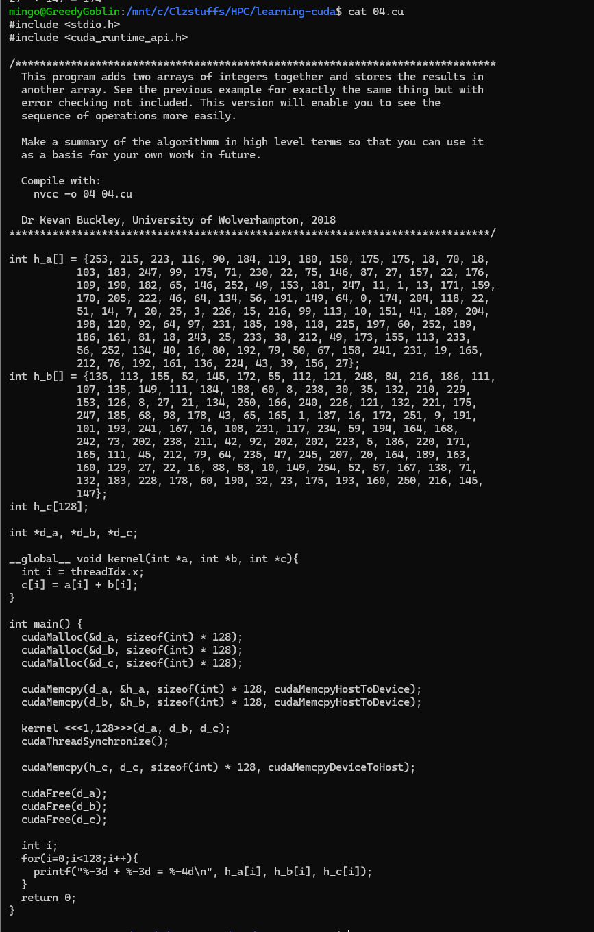
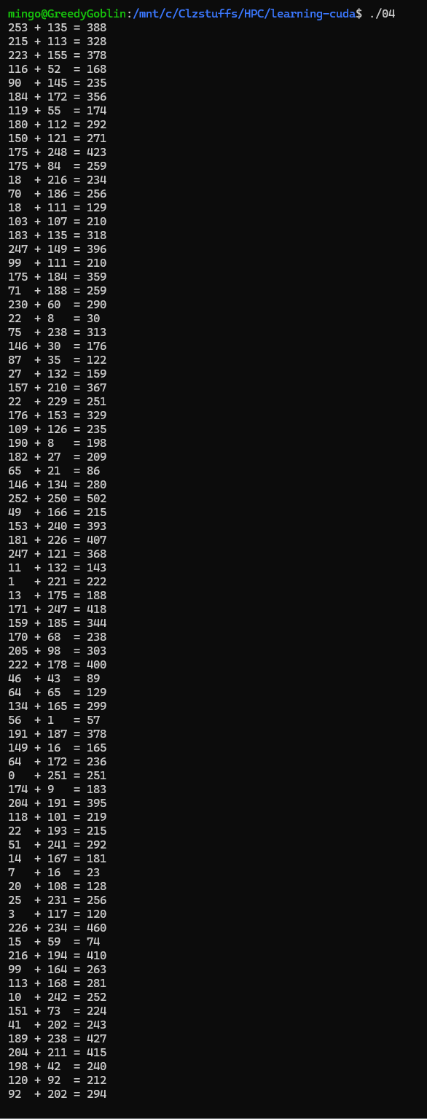
This program adds two lists of numbers together and saves the result in a third list. It is identical to the previous example but removes the error-checking code to make the steps easier to follow. By simplifying the code, you can more clearly see the exact sequence of operations the GPU uses to complete the task.
5.
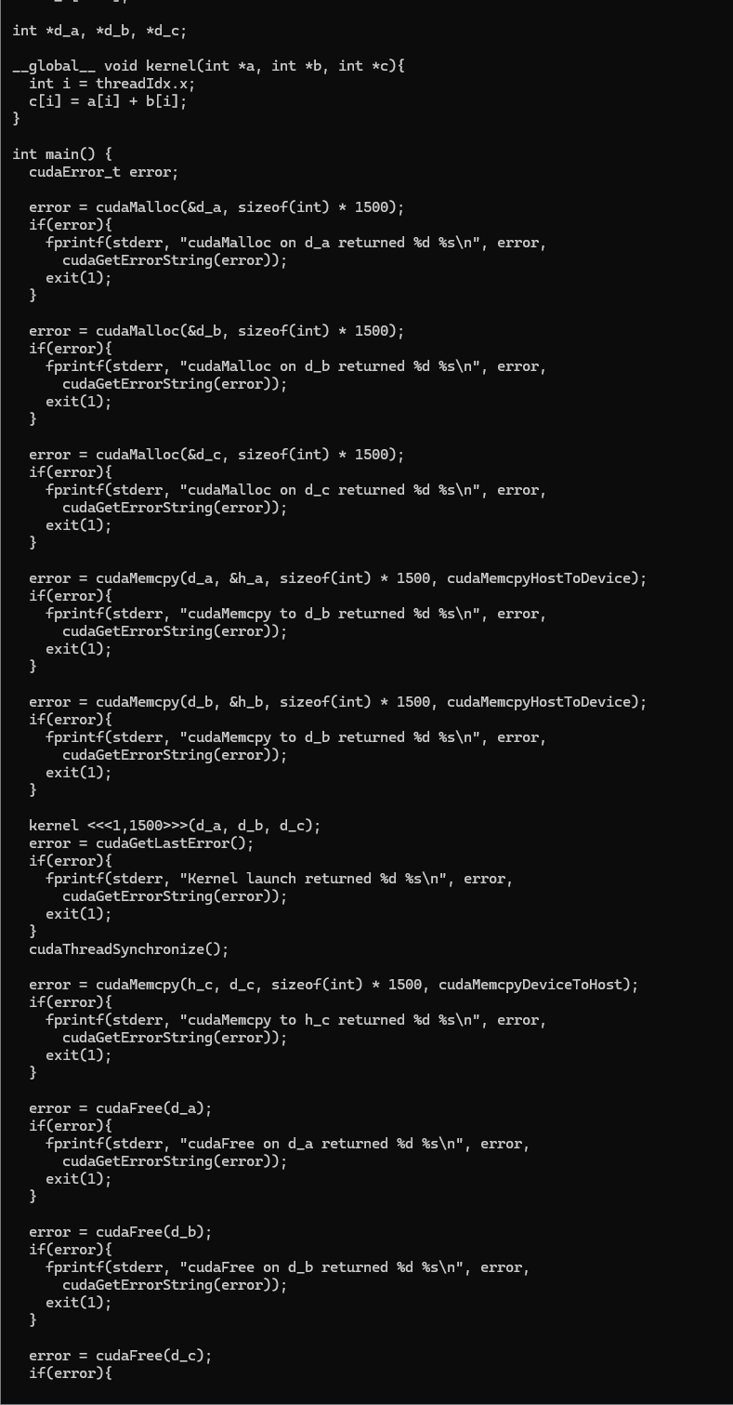
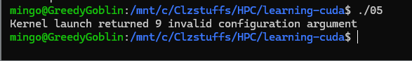
This program attempts to add two large lists of numbers, but it will likely fail because the data is too big for a single group of threads. Since most GPUs have a limit of 512 threads per block, this code is designed to show you what a "kernel launch failure" looks like when you exceed that limit. Additionally, the program is purposely inefficient because it doesn't clean up its used memory, resulting in a memory leak.
6.
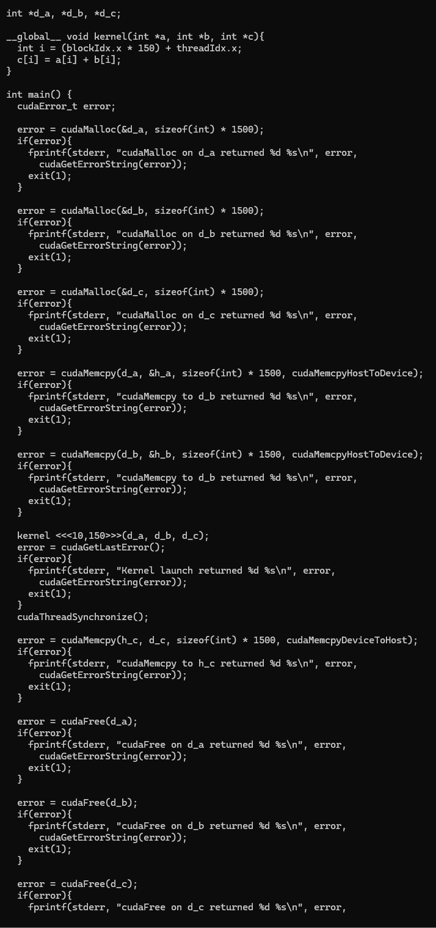
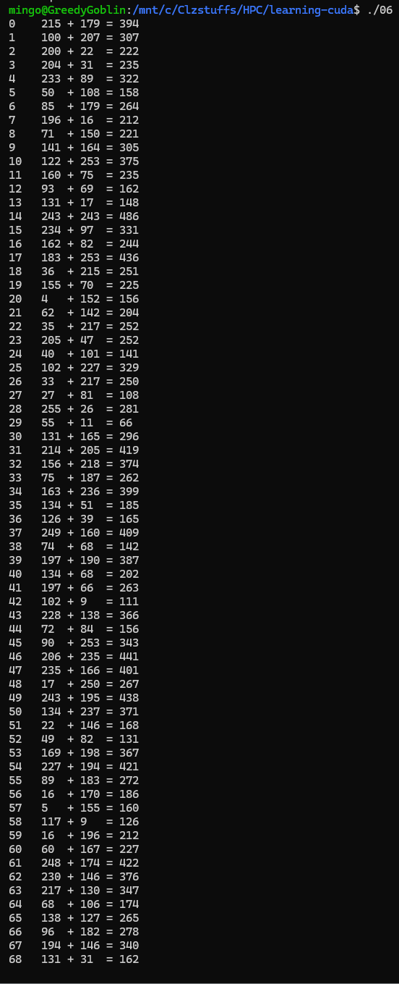
This program adds two large lists of numbers together while carefully staying within the GPU's thread limits. Because the data is so big, the program calculates a unique ID for every individual thread to ensure each one knows exactly which piece of information to process. This approach allows the GPU to handle massive amounts of data correctly by splitting the work across many organized groups of threads.

factorise_3_cuda.
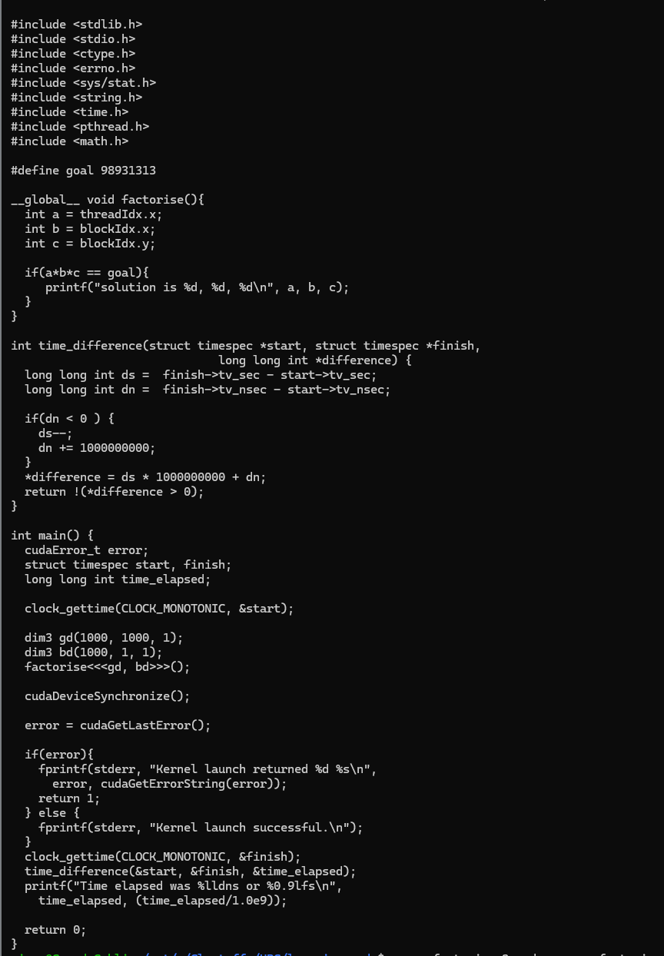
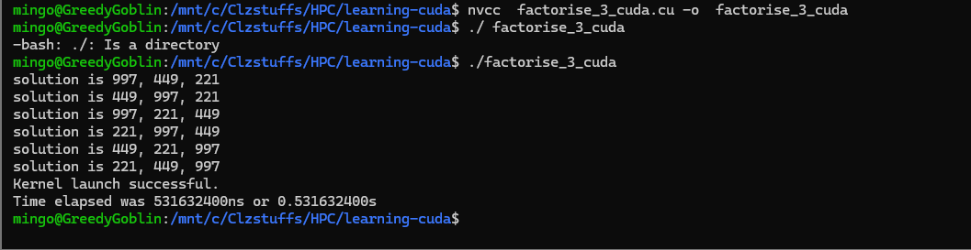
This program performs the same task of breaking down numbers into factors as the previous versions we studied with CPU threads. The main difference is that this version is designed to run on a GPU using CUDA, allowing the graphics card to handle the mathematical calculations instead of the main processor.

